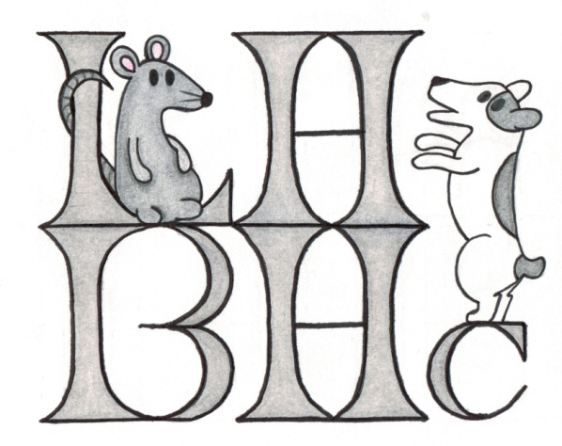

540-439-PAWS (7297) FAX 540-439-8021

libertyhillpet@aol.com

Barn Hunt Run-Thrus with Liberty Hill Barn Hunt Club
10401 Green Road. Bealeton, VA 22712
October 25th, 2020 starting at 12:00 pm

Open to all dogs, dogs do not need to be registered with BHA, LLC
Fee: $10.00 per run or $25.00 for three runs for Instinct, Novice and Open.
Fee: $15.00 per run or $40.00 for three runs for Senior and Master.
Registration closes on October 23rd.

We will be offering Barn Hunt Run-Thrus starting at 12 pm with Instinct. We will then move to Novice, Open, Senior and Master. You may sign up for multiple runs with multiple dogs. Please fill out a separate form for each dog and let us know how many runs you would like to participate in the blanks below. You will have 5 minutes per run for Instinct, Novice and Open. Senior and Master runs will have 10 minutes. We will need your assistance for keeping everything running smoothly. We will need rat wranglers, gate stewards, leash holders, course builders and time keepers. Please wear a mask.
Please bring proof of vaccinations when you come. We need Rabies, Distemper, Canine Influenza and Bordetella. No prong or slip chain collars allowed.
Once we have received all the applications and checks, we will schedule the runs and let you know an approximate time.
Please bring secure crates for your dogs, so you can leave them unattended while you watch and learn as other dogs and handlers work. Don’t forget water for your dog.

NAME__________________________________________PHONE_______________________ADDRESS____________________________________________________________________EMAIL________________________________________ DOG’S AGE______ M or F(circle) DOG’S NAME _____________________________ BREED___________________________
Instinct _________ Novice _________ Open _______ Senior _______ Master ________ (Please write number of runs in the blanks)
Liability Waiver I (we) acknowledge that if this application for the entry of this dog is made available to me (us) for participation in a Barn Hunt event, that I (we) agree that this facility has the right to refuse the entry of this dog and/or they reserve the right to dismiss the dog and myself for cause which Barn Hunt deems to be sufficient. I understand that attendance at an event or class is not without risk to myself, members of my family, any of my guest(s) who may attend or my dog (s). In consideration of the acceptance of this and the opportunity to train my dog(s), I (we) agree to hold Barn Hunt Association, LLC, Liberty Hill Pet Resort, Liberty Hill Barn Hunt Club and all assistants and associates harmless from any claim for loss or injury which may be alleged to have been caused directly or indirectly to any person or thing by the act of this dog or dogs while in or upon the premises or grounds or near any entrance thereto, and I (we) personally assume all responsibility and liability for such claim, and I (we) further agree to hold the aforementioned parties harmless from any claim for damage or injury to the dog(s) or myself, or members of my family, either physically or mentally, whether such loss, disappearance, theft, damage or injury, be caused or alleged to be caused by negligence while in or upon the premises of the Barn Hunt grounds. The terms of this agreement bind the parties for the current period of training, and all subsequent classes/training/events in which they hereafter participate.

I/we certify that I/we do not, to my/our knowledge, have COVID-19 at the time of attending this event. Nor have I/we been in contact with or exposed to any known carrier of COVID-19 within the past 14 days. If I/we have had the virus, I/we certify that we have had at least two negative tests 14 or more days prior to the Event or have had a positive antibody test, and have been released by government officials and/or health care providers to resume normal activity without limit. I/we understand that we have entered and are competing at this Barn Hunt event entirely at my/our own risk and take full responsibility for my/our own health and safety during this Event. I/we pledge to follow all Barn Hunt Association and specific Club Event rules and requirements to mitigate any possibility of infecting others or becoming infected. I/we will also cooperate with any health department and/or State/ Local guidelines that have jurisdiction in the area in which the Event is taking place. The Barn Hunt Association LLC and the Liberty Hill Pet Resort are in no way liable for any present or future COVID-19 infection incurred at any time by any person, in attendance or not in attendance, before, during or after this Event.
Signature _______________________________________________________ Date________________

